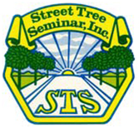
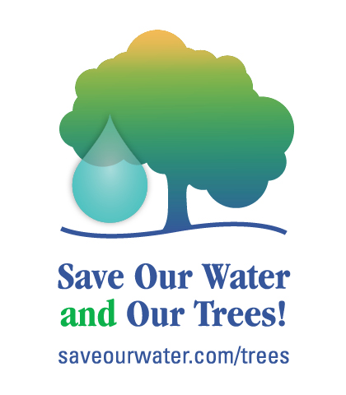
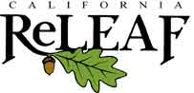

PRESS RELEASE: FOR IMMEDIATE RELEASE July 23, 2015

Media Contacts
Al Remyn/Rose Epperson/Heather Crippen Cindy Blain
Street Tree Seminar, Inc. California ReLeaf
714/639-6516 (916) 497-0034
info@streettreeseminar.com cblain@californiareleaf.org

Save Our Water And Our Trees! Campaign Offers Tips to Help Trees Thrive

Sacramento, CA – STREET TREE SEMINAR, INC. has partnered with California ReLeaf, Save Our Water, and a coalition of urban forest and other concerned organizations to raise awareness on the importance of proper tree care during this historic drought. Save Our Water is California’s official statewide conservation education program. California ReLeaf is a statewide urban forest nonprofit providing support and services to over 90 community nonprofits that plant and care for trees.
With potentially millions of urban trees at risk, this campaign focuses on a simple yet urgent message: Save Our Water and Our Trees! The Save Our Water and Our Trees partnership is highlighting tips for both residents and agencies on how to water and care for trees so that they not only survive the drought, but thrive to provide shade, beauty and habitat, clean the air and water, and make our cities and towns healthier and more livable for decades to come.
“While Californians cut back on water use during the drought, it is critical to community health to save our lawn trees by setting up alternative watering systems once you turn off the regular sprinklers,” said Cindy Blain, Executive Director of California ReLeaf.
Lawn trees can and must be saved during the drought. What you can do:
- Deeply and slowly water mature trees 1 - 2 times per month with a simple soaker hose or drip system toward the edge of the tree canopy – NOT at the base of the tree. Use a Hose Faucet Timer (found at hardware stores) to prevent overwatering.
- Young trees need 5 gallons of water 2 - 4 times per week. Create a small watering basin with a berm of dirt.
- Shower with a bucket and use that water for your trees long as it is free of
non-biodegradable soaps or shampoos.
- Do not over-prune trees during drought. Too much pruning and drought both stress your trees.
- Mulch, Mulch, MULCH! 4 - 6 inches of mulch helps retain moisture, reducing water needs and protecting your trees.
Trees in irrigated landscapes become dependent on regular watering and when watering is reduced – and especially when it’s stopped completely – trees will die. Tree loss is a very costly problem: not only in expensive tree removal, but in the loss of all the benefits trees provide: cooling and cleaning the air and water, shading homes, walkways and recreation areas as well as human health impacts.
“This summer it is vital that Californians limit outdoor water use while preserving trees and other important landscaping,” said Jennifer Persike, Deputy Executive Director of External Affairs and Operations, Association of California Water Agencies. “Save Our Water is urging Californians to Let It Go – GOLD this summer, but don’t forget to keep your trees healthy.”
Save Our Water has been urging Californians to “Let It Go” this summer by limiting outdoor water use and letting lawns fade to gold, while preserving precious water resources for trees and other important landscapes.
Save Our Water’s website is available in both English and Spanish and is filled with tips, tools, and inspiration to help every Californian find new and creative ways to conserve. From tips on how to keep trees healthy during the drought to an interactive section allowing users to visually explore how they can save water both inside and outside the home, Save Our Water has a wealth of resources available for Californians.
STREET TREE SEMINAR, INC. is an organization dedicated to the development, health care and management of street trees in rural and urban areas within southern California. The membership consists of professional tree managers, arborists and associated organizations and companies.
# # #

